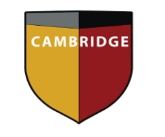
Cambridge International School
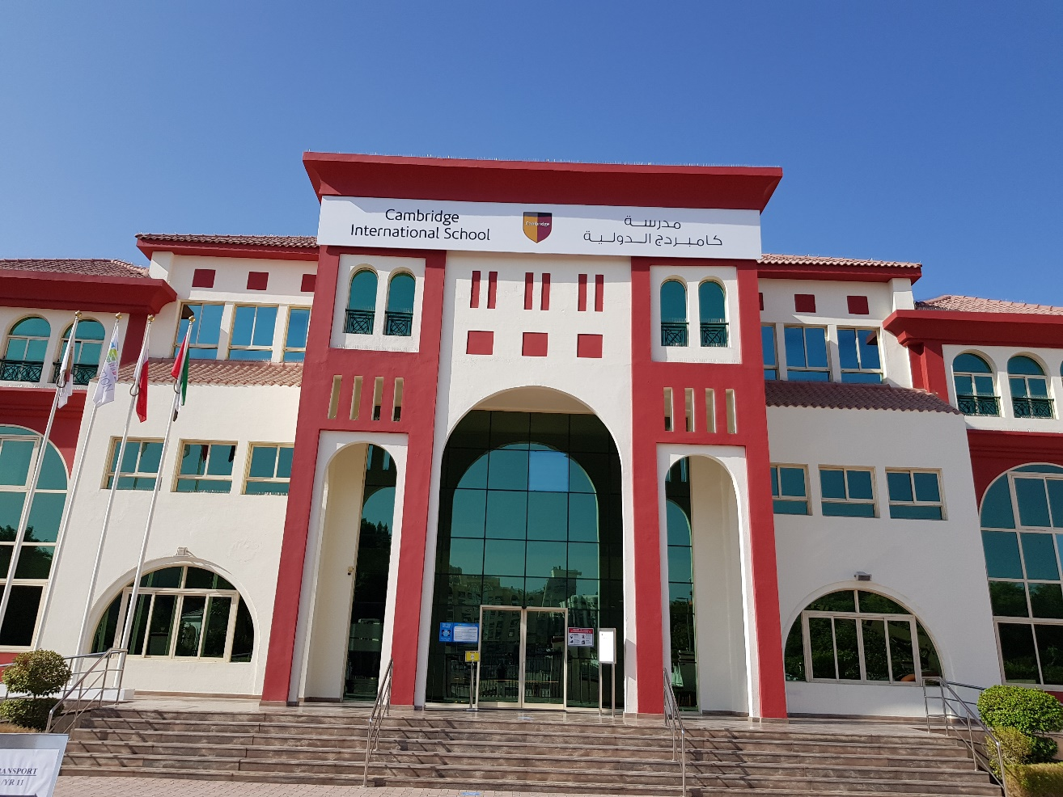
Dubai
Key Stage 3 Curriculum

Year 9 Option Form
2021-2022

Year 9 - List of IGCSE Subject Choices 2021-2022

Student Name______________________________ Form______________________________

Year 9 students will continue to study the Key Stage 3 National Curriculum. Students will select One IGCSE subject. The course will run for two years and at the end of these two years in Year 10, students will sit the external examination.

National Curriculum Subjects | MOE Subjects | IGCSE Subject
English | Arabic (A & B) | *French
Mathematics | Islamic Studies/ PSHE | *Sociology
Science | Social Studies | *Computer Science
Humanities | Moral Education | **ICT
Physical Education |  | **Business

* This subject will not be offered as a new subject again in Year 10 (2022-2023)
** This subject will be offered as a new subject again in Year 10 (2022-2023)

Please select your first and second preference.

IGCSE Subject
First Preference
Second Preference

The selected subjects are preferences and subject confirmation is dependent on course numbers, teacher recommendations and CAT4 scores.

I, (student name) ______________________________ in class_____ confirm my preferred choice and

recognise that this may be amended after consultation.

Signed________________________ Date ________________

