Cambridge International School
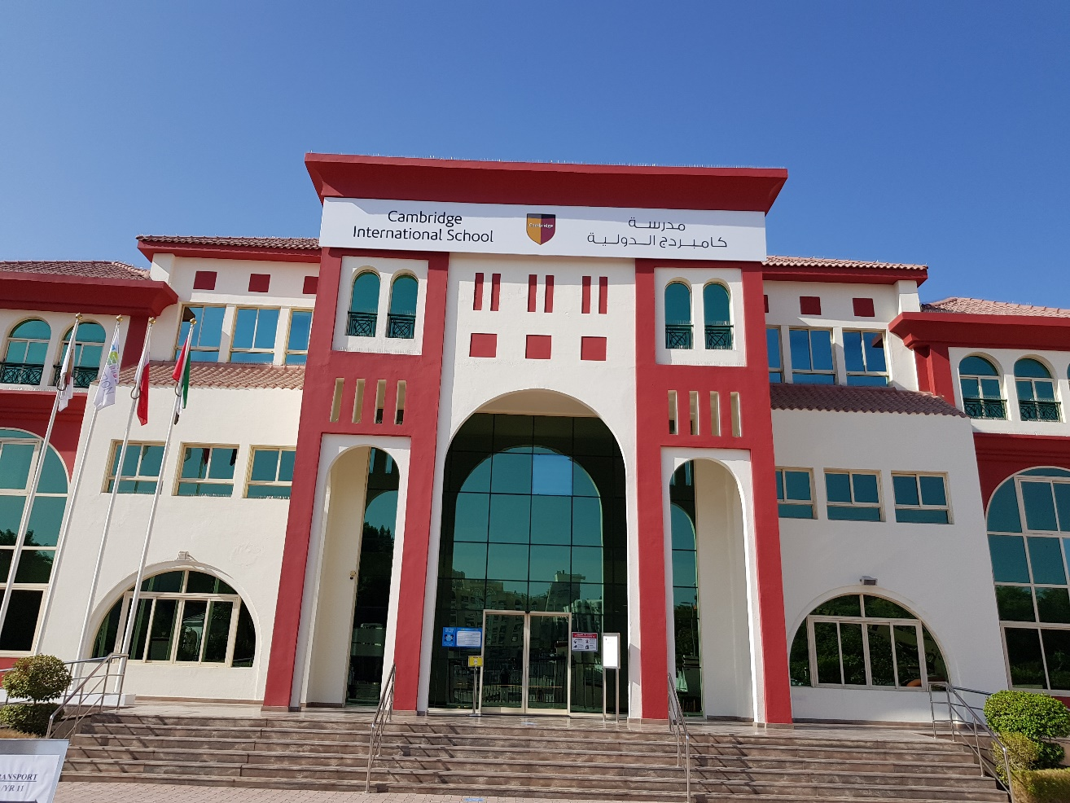
Dubai

Post 16 Application Forms
2021-2022

Post 16 2021-22 Application form
Year 12
Personal Details
Name (as in passport):
Date of Birth:
Gender:
Name of Present School:

Parents Details
Title: Name (as in passport): Tel No:
Email address:
Title: Name (as in passport): Tel No:
Email address:

Subjects being taken at IGCSE:
Subject | Term 2 Grade | Mock 2 Grade |  | Subject | Term 2 Grade | Mock 2 Grade
1 |  |  |  | 6
2 |  |  |  | 7
3 |  |  |  | 8
4 |  |  |  | 9
5 |  |  |  | 10

Year 12 Options Selection

Option Choice | Subject  (Minimum 4)
Option 1
Option 2
Option 3
Option 4

Note: - All students must complete 4 subjects. Please be aware that some subjects may not run if there are insufficient numbers of students to make the course viable.

Please fill out the following sections in as much detail as possible:

Interests in and out of school (e.g. involvement with clubs/teams/groups/drama, music, sport, etc. as well as individual interests):

Any positions of responsibility (e.g. prefect, sports captains, school council):

Any awards received/qualifications gained (e.g. school prizes, music exams):

What career plans do you have?

Any other information you wish the school to be aware of:

Please note:

- All students need to complete the application form accurately.

- All students need to have a completed confidential reference form. For internal candidates this form should be completed and given to your Learning Manager along with the relevant subject choices. Learning Managers will complete your reference.

- External candidates must send this reference form and option choices to the school along with the application form.

- The signed Post 16 contract MUST be completed and signed before an interview can take place.

Reference Form

Internal candidates
Dear Learning Manager, please comment on the student’s attitude towards his/her IGCSE studies, contribution to school life and their ability to cope with an A Level programme as well as punctuality and attendance. Your accurate view of the student will be highly appreciated in a way for us to come to a decision.

External Candidates
Please attach a reference to your application form, this must be on school headed paper with your school stamp.

Signature of Teacher:

Name:

Position:

Notes for Cambridge students:

Write down your grades in the table above. A reference from your Learning Manager is essential. The Learning Manager must give the completed reference form directly to the Post 16 team as this is a confidential document.
It is important to note that the payment of the re-enrollment fee will be considered the booking fee, after which only the student be qualified for an interview with the Sixth Form selection team. This fee must be paid before we begin the interview process in April 2021. Your place on a course will only be confirmed if you achieve the grades you have been asked for. As soon as the results are declared in August 2021 you must re-confirm with us that you have met the admission criteria set by Cambridge International School. A copy of your examination results needs to be brought into school, so we can fully process your application, along with the required school fees.

Notes for External applicants (Non-CIS students):

New students applying to CIS need to get the predicted grades in the subjects opted at the IGCSE/GCSE from their current school teachers along with a reference.
Your place on a course will only be confirmed if you achieve the grades you have been asked for. As soon as the results are declared in August 2021 you must re-confirm with us immediately that you have met the admission criteria set by Cambridge International School. A copy of your examination results needs to be brought into school, so we can fully process your application, along with the required first term school fees.

If you are applying from a different curriculum, such as Indian curriculum, placements will not be confirmed until August 2021.

I confirm the information in the application form to be true.

Students Signature……………………………… Date…………………………..

Parents Signature……………………………… Date…………………………..

Post 16 2021-22 Application form
Year 13
Name: Class:

- Subjects studied in Year 12:

1. 2. 3. 4.

Intentions for 2021-22

If you are continuing:

- Subjects planning to study in Year 13 (minimum 3 choices as per the option block):

1. 2. 3. 4.

If you are leaving:

- Where to?

- Which course?

- Contact details:

- E-mail address:

If you are undecided on what you are going to do, please complete the sections below to provide more details:
What factors are causing you to be undecided? (please note those that might be making you want to stay and those that might be make you consider leaving)

What might you be looking to study outside of CIS and where are you considering?

What additional help/advice do you need? And do you know where you can get this from?

CAMBRIDGE INTERNATIONAL SCHOOL DUBAI
Post 16 Community Contract
2021-2022

Student’s Name: ___________________________________ Form: ___________________

We understand that my son/daughter____________________ has accepted a place at Cambridge International School Post 16 Community conditional upon the following requirements being met at all times.

(Name)____________________________ shall:

- Attend all school lessons and other activities within their Post 16 timetable regularly and punctually
- Be present for every registration session and shall attend assemblies as required
- Use any non-timetabled time for individual private study in allocated areas
- Not leave the school site during lesson time unless previously agreed and discussed with the Head of Year 12 or the Head of Year 13 respectively and in consultation with parents
- Wherever possible make routine appointments with the doctor, dentist etc. outside of school hours.
- Adhere to the Post 16 Dress Code by being smart and presentable at all times
- Meet all deadlines set for homework and coursework for all subjects
- At all times set a good example to the younger students in the school
- Behave in an exemplary manner in accordance with the school’s Code of Behaviour
- Respect his/her surroundings and recognize the right of other students to study in peace
- Notify the Learning Managers / Head of Year 12 or the Head of Year 13 respectively in case of absence
- Will use any study lessons effectively and be at the correct designated place
- Will complete the required community service hours during the designated days and complete the log book
I/We agree that_____________ shall meet the above requirements at all times and understand that failure to do so will result in a meeting to discuss her/his continuing education at Cambridge International School Post 16 Community.

We have also read and understand the requirements and expectations of the courses being opted for.

Signed_________________ (Parent) Signed_______________________(Student)

Parent’s Name_______________________ Date_________________________

